SQA ASSIGNMENT 1

M. Ammar Ahmad 231492719

# TEST CASE 1:

In first test case doc testing is used. The function takes two inputs and subtract them and if the test cases are correct there would be no errors in the cmd.

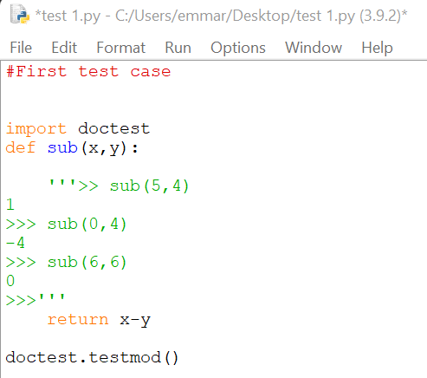

If we change the - sign to * as follow

The output would be:

# Test Case 2:

In second test attribute testing is used to test the program. A condition is made within the program and if the result is according to that, the program is considered successful.

Result with the correct answers in test cases:

If the program is changed as follow:

The answers are changed

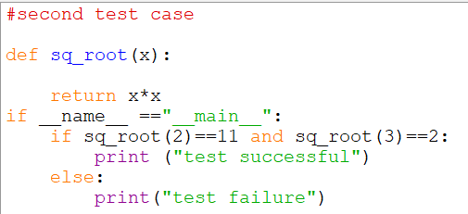

The output would be:



# Test case 3:

In program attribute testing is used just like the previous one with the exponential function.

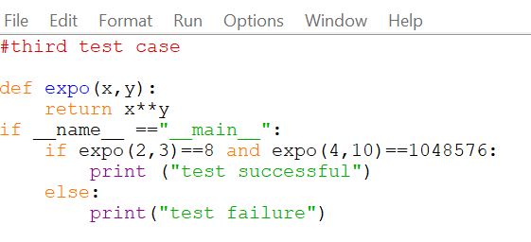

When the answers are changed in the cases, the output would be test failure and if they are correct the output would be test successful.

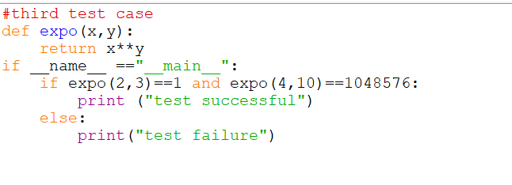



# Test case 4:

In test case 4, unit testing technique is used to test the program.If the test is successfully executed Ok is printed and if there is a failure F is printed on the prompt.

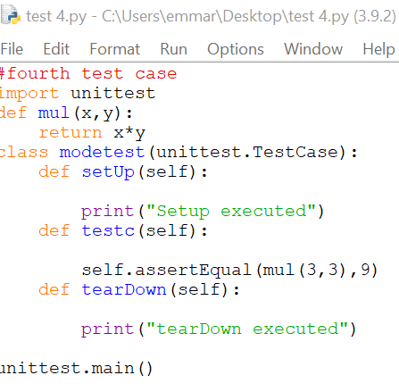

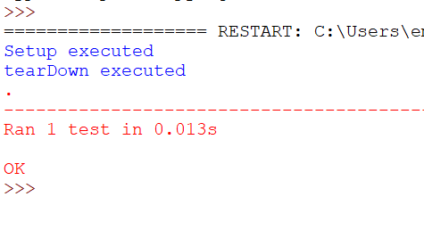

If the output result is changed from 9 to some other number:

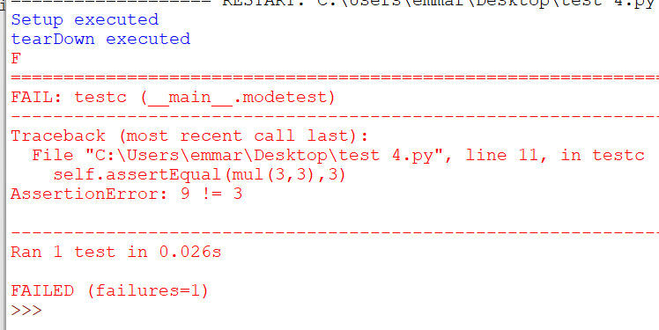

# TEST CASE 5:

In test case 5 doctest technique is used just as the test case 1 where the conditions are provided and the answers are compared to the expected output.

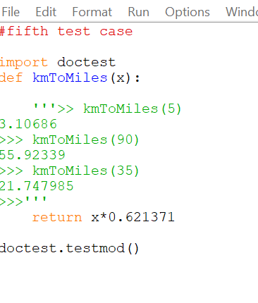

When this program is executed there are no errors displayed. And when the wrong answers are provided within the program the following output is displayed.

